Dimensionality Reduction Techniques: A Comparative Study of PCA, t-SNE, and MDA

Prepared by: Shenouda Safwat
Subject: Dimensionality Reduction Machine Learning
Date: 03/ 2026

1-Abstract
Dimensionality reduction is a critical preprocessing step in modern data science. As datasets grow in complexity, the "curse of dimensionality" makes visualization and model training increasingly difficult. This research explores three foundational techniques: Principal Component Analysis (PCA), t-Distributed Stochastic Neighbor Embedding (t-SNE), and Multiple Discriminant Analysis (MDA). We discuss their mathematical logic, strengths, and ideal use cases.
2-Introduction
In high-dimensional datasets, many features are often redundant or represent noise. Dimensionality reduction aims to project this data into a lower-dimensional space (2D or 3D) while preserving as much significant information as possible. This process is essential for data compression, noise filtering, and human-interpretable visualization.

3-Principal Component Analysis (PCA)
3.1 Definition
PCA is a linear, unsupervised transformation technique. It was introduced by Karl Pearson in 1901 and remains the standard for variance-based reduction.
3.2 Methodology
PCA works by identifying the "Principal Components"—new orthogonal axes that capture the maximum variance in the data.
- Step 1: Standardize the dataset.
- Step 2: Compute the Covariance Matrix.
- Step 3: Calculate Eigenvectors and Eigenvalues.
- Step 4: Project the data onto the top-ranking Eigenvectors.

3.3 Key Characteristics:
- Efficiency: Extremely fast and scalable.
- Global Structure: It preserves the global arrangement of data points.
- Limitation: Since it is a linear method, it cannot capture complex non-linear relationships (e.g., a "Swiss roll" dataset).

4-t-Distributed Stochastic Neighbor Embedding (t-SNE)
4.1 Definition
Introduced by Maaten and Hinton (2008), t-SNE is a non-linear, unsupervised algorithm primarily used for high-dimensional data visualization.
4.2 Methodology
Unlike PCA, t-SNE focuses on maintaining the local structure of the data.
It calculates the probability that pairs of points are neighbors in high-dimensional space.
It then recreates these probabilities in a low-dimensional space using a Student’s t-distribution to ensure that nearby points stay together and distant points remain separated.
4.3 Key Characteristics
Visualization: Superior at revealing clusters and sub-groups.
Computation: Computationally intensive (slow for very large datasets).
Limitation: The results (distances) are not always preserved globally; it is strictly for exploration, not for feature engineering in predictive models.
5-Multiple Discriminant Analysis (MDA)
5.1 Definition
MDA (often associated with Linear Discriminant Analysis - LDA) is a supervised linear technique. It requires class labels to function.
5.2 Methodology
The goal of MDA is class separation. While PCA looks for maximum variance, MDA looks for the axes that:
Maximize the distance between the means of different classes.
Minimize the variance within each class.
5.3 Key Characteristics
Supervised: Uses category information to improve the projection.
Classification: Ideal as a preprocessing step before running a classifier (like SVM or Random Forest).
Assumption: Assumes the data follows a normal (Gaussian) distribution.

6-Advanced Technical Nuances (The "Deep" Insights)
PCA: The Dominance of SVD over Covariance
While textbooks often define PCA through the Eigendecomposition of the Covariance Matrix, modern computational implementations (like Scikit-Learn) rarely use this approach. Instead, they employ Singular Value Decomposition (SVD) directly on the centered data matrix.
- The Depth: Computing the covariance matrix is computationally expensive (O(p^2n)) and can lead to numerical instability. SVD bypasses the covariance matrix entirely, providing better numerical precision and handling sparse datasets more efficiently.

t-SNE: The Illusion of Global Distance
A common misconception in t-SNE visualization is that the distance between separated clusters represents their actual dissimilarity in the high-dimensional space.
- The Depth: t-SNE is designed to preserve local topology, meaning it only ensures that points that were close together remain close. Because the algorithm uses a "Perplexity" hyperparameter to balance local and global attention, the "empty space" or distance between clusters in a 2D plot is essentially arbitrary and should not be used to infer global relationships between different groups.

MDA: The Hard Dimensionality Constraint
Researchers often attempt to reduce data to a specific number of components using MDA, only to find the algorithm capable.
- The Depth: The rank of the "Between-Class Scatter Matrix" in MDA is mathematically limited to C − 1, where C is the number of unique classes. For example, in a binary classification (2 classes), MDA can only project the data onto one single dimension, regardless of how many thousands of input features you started with. This makes MDA a "bottleneck" technique when the number of categories is small.
8-"The following figures provide a comparative visual analysis of PCA, t-SNE, and MDA methodologies."
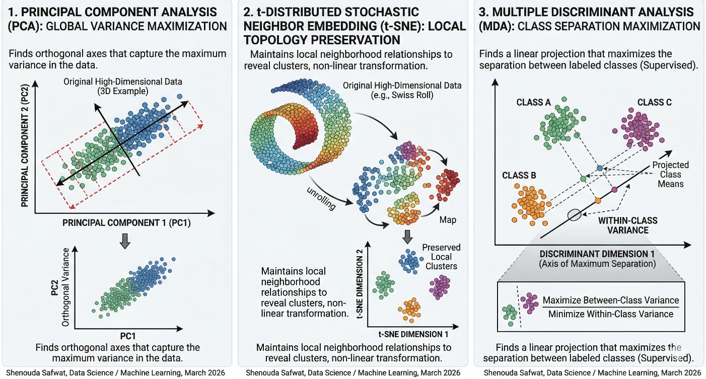

7-Conclusion
Choosing the right technique depends on the objective. PCA is best for general noise reduction and compression. t-SNE is the gold standard for visual data exploration and finding clusters. MDA is the most powerful when class labels are known and the goal is to optimize a classification model.

8-References
- Jolliffe, I. T. (2002). Principal Component Analysis. Springer Series in Statistics.
- Van der Maaten, L., & Hinton, G. (2008). "Visualizing data using t-SNE." Journal of Machine Learning Research.
- McLachlan, G. J. (2004). Discriminant Analysis and Statistical Pattern Recognition. Wiley-Interscience.
- Bishop, C. M. (2006). Pattern Recognition and Machine Learning. Springer New York.

